Ankara Üniversitesi Tıp Fakültesi Mecmuası 2016, 69 (3)

DAHİLİ BİLİMLERİ/ MEDICAL SCIENCES | DOI: 10.1501/Tıpfak_000000942
Araştırma Makalesi / Research Article | DOI: 10.1501/Tıpfak_000000942

Effects of Static Stretching on Quadriceps Peak Torque and Hip Range of Motion in Professional Soccer Players and Sedentary Subjects

Statik Germenin Profesyonel Futbolcularda ve Sedanterlerde Kuadriseps Pik Tork ve Kalça Hareket Açıklığı Üzerindeki Etkileri

Mehmet Mesut Çelebi1, Savaş Kudaş2, Ali Murat Zergeroğlu1

- Sports Medicine Department, School of Medicine, Ankara University, Ankara, Turkey.
- Gençlerbirliği Sport Club, Ankara, Turkey

Aim: Static stretching (SS) is commonly performed by athletes prior to exercise and athletic events for many years. Its possible benefits are based on increases in joint Range of Motion (ROM) and/or decreases in muscle-tendon unit stiffness. The purpose of this study was to investigate the effects of static stretching on concentric, isokinetic leg extension peak torque (PT) at 60 and 300°·s−1 and hip range of motion (ROM) in sedentary people and professional soccer players.

Methods: This study was performed at Ankara University School of Medicine between June 2013 and October 2014. 30 male subjects; 15 sedentary subjects (aged 21.5 ± 3.7 years, body mass 72.6 ± 13.3 kg, height 177.8 ± 6.6 cm) and
15 soccer players (aged 18.7 ± 0.5 years, body mass 73.7 ± 4.7 kg, height 181.6 ± 4.2 cm) volunteered to participate in this study. Thigh extensor muscle strength was measured by isokinetic dynamometer at speeds of 60 and 180 degrees and hip ROM was measured with goniometer in both groups with and without stretching.

Results: There were no significant differences pre- and post- stretching PT; both isokinetic velocities on the soccer players and sedentary subjects. However, ROM increased (p < 0.05) post-stretching compared with pre-stretching in both groups.

Conclusion: We concluded that 30 seconds SS can not affect muscular performance but improved flexibility. Thirty second stretching exercises as part of a warm-up to be proposed to the coaches.

Key Words: Static Stretching, Peak Torque, Soccer Player, Range of Motion

Amaç: Statik germe uzun yıllardır sporcular tarafından egzersiz ve sportif faaliyetler öncesinde yaygın bir şekilde ya-pılmaktadır. Olası faydaları eklem yerlerinde hareket açıklığındaki artışlara ve/veya kas-tendon birim sertliğindeki azal-malara dayandırılmaktadır. Bu çalışmanın amacı sedanterlerde ve profesyonel futbolcularda statik germenin 60 ve 300°·s−1 hızda konsantrik, izokinetik bacak ekstansiyon pik torku ve kalça hareket açıklığı üzerindeki etkilerini incele-mektir.

Yöntem: Bu çalışma Ankara Üniversitesi Tıp Fakültesi’nde Haziran 2013 ve Ekim 2014 tarihleri arasında yürütülmüştür. Çalışmaya15 sedanter (21.5 ± 3.7 yaşlarında, vücüt kitlesi 72.6 ± 13.3 kg, boy 177.8 ± 6.6 cm) ve 15 futbolcu (18.7 ± 0.5
yaşlarında, vücut kitlesi 73.7 ± 4.7 kg, boy 181.6 ± 4.2 cm) olmak üzere 30 erkek denek gönüllü olarak katılmıştır. Her iki grubun uyluk ekstansör kas kuvvetleri isokinetik dinamometre ile 60 ve 180 derece hızlarda ve kalça hereket açık-lıkları goniometre ile germe yapılmadan ve germe yapıldıktan sonra ölçülmüştür.

Sonuçlar: Germe öncesi ve sonrasında; hem futbolcularda, hem de sedanter deneklerde her iki izokinetik hızda kayda değer bir farklılık bulunmamıştır. Ancak, her iki grupta da germe öncesi ile karşılaştırıldığında germe sonrası kalça ha-reket açıklığının arttığı (p < 0.05) görülmüştür.

Tartışma: Otuz saniyelik statik germenin kas performansını etkilemediği ancak esnekliği iyileştirdiği sonucuna ulaşıl-mıştır. Antrenörlere ısınmanın bir parçası olarak 30 saniyelik germe egzersizleri önerilebilir.

Anahtar Sözcükler: Statik Germe, Pik Tork, Futbolcu, Eklem Hareket Açıklığı

Received : Oct 04,2016 • Accepted: Nov 04,2016

Corresponding Author:

Mehmet Mesut Çelebi

E-mail: mcelebi@ankara.edu.tr
Phone: +90 (312) 562 22 80

Sports Medicine Department, School of Medicine, Ankara University, Ankara, Turkey.

Static stretching (SS) has long been used by athletes usually before exercises and sports activities (1). It is believed that stretching before exercises lowers the risk of injury and increases flexibility (2-4). An increase in flexibility (increasing the range of motion of joints) is expected to improve performance and lower the risk of injury during sports activities.

Possible benefits of static stretching are based on the increase in the range of motion (ROM) of the joint or the decrease in the stiffness of the muscle-tendon unit. Reduction in muscle-tendon unit stiffness is considered to decrease the production of force in the muscle being stretched, thereby protecting against injury (5-8).

Ankara Üniversitesi Tıp Fakültesi Mecmuası 2016, 69 (3)

However, the potential benefits of stretching prior to exercise have recently been receiving a great deal of criticism. It has been concluded that stretching prior to sports activities does not lower the risk of all injuries, but it is believed to lower the risk of some injuries (9).

In recent systematic reviews and many original studies, the authors state that stretching before excercise temporarily decreases force production in the muscle (1,3,4,6,10-16). On the other hand, most studies do not show a negative effect of static stretching on strength performance (2,17-26). Some authors suggest that duration of stretching would certainly have an effect on performance. For example, Ogura et al. (19), in their study comparing isometric knee flexion force production after no stretching, 30 seconds of SS, and 60 seconds of SS, found that significantly lower force was produced after 60 seconds of stretching, whereas the difference was not significant after 30 seconds of stretching. Similarly, Young and Elliot

- in their study exploring the effect of 1, 2, and 4 minute SS on drop jump performance, showed that 2 and 4 minute SS significantly decreased drop jump performance, whereas 1 minute SS did not. There is clearly a need for further research to fill the knowledge gap in the effect of static stretching on peak torque of muscle.

The purpose of this study is to investigate the effect of stretching on peak torque (PT) during concentric isokinetic leg extension at the speeds of 60 and 300 degrees per second and hip ROM in sedentary people and soccer players.

2. Methods

2.1. Participants

This study was performed at Ankara University School of Medicine between June 2013 and October 2014. A total of 30 male participants, 15 sedentary

people (age 21.5 ± 3.7 years, body mass 72.6 ± 13.3 kg, height 177.8 ± 6.6 cm) and 15 soccer players (age 18.7 ± 0.5 years, body mass 73.7 ± 4.7 kg, height 181.6 ± 4.2 cm), were enrolled in our

study. The participants were healthy, and they had neither current or recent lower extremity injuries nor an apparent restriction in the ROM of their knees.

The study was approved by the ethics board of Ankara University. Before the tests, all participants were informed about the study, and their consents to participate in the study were obtained.

2.2. Design

A randomized, within-participants, and balanced experimental design was used in order to compare the short-term effects of static stretching on quadriceps peak torque and hip range of motion in sedentary participants and professional soccer players.

The participants served as their own control groups. The study was done on three test days. On the first day, the participants were familiarized with the testing procedures. On the second and third days, randomized measurements with and without stretching were done. The duration of static stretching was approximately 20 minutes for each participant. On the day without stretching, the participants were tested after waiting for 20 minutes. The participants were tested after an equal duration of time in measurements both with and without stretching.

2.3. Peak Torque Measurements

Each participant warmed up for 5 minutes at 30 W on a bicycle ergometer before the isokinetic test measurements were done. Prior and subsequent to the

static stretching protocols, measurement of maximal concentric isokinetic PT for extension of the dominant extremity (according to kicking preference) was done at speeds of 60 (5 repetitions) and 300 degrees per second (10 repetitions) at a randomly selected order. Three sub-maximal warm-up exercises were done before the test at both speeds. Between the measurements at these speeds, a two-minute resting period was given.

2.4. Range of Motion
Measurements

Hip extension angle was measured immediately before and after stretching. In accordance with the anatomical landmarks that were previously described by other authors, a goniometer was placed laterally along the dominant lower extremity. The central point of the goniometer was fixed on the lateral femoral condyle, and the proximal arm was aligned with the femur using the greater trochanter as the reference point. The lateral condyle was used as the reference point when positioning the distal arm of the goniometer along the leg. Two measurements were made, and the ROM scores were determined by calculating the average of these two measurements.

2.5. Stretching Exercises

Each participant did four exercises to stretch the extensor muscles of the dominant lower extremity in accordance with the procedures described in a previous study (14). Each of the four stretching exercises took 30 seconds. The stretching applied was enough to induce discomfort, but it was below the threshold of pain. The leg was brought back to a neutral position for 20 minutes in order to rest the leg between stretchings. For each participant, the average duration of stretching was 20 minutes. The participants did three assisted and one unassisted stretching exercises. Assisted exercises were done with the participant standing in an upright position. The participants leaned on the wall to keep their balance. The participants held their dominant lower extremities in a position of 90 degrees of flexion at the knee and subsequently pulled their heels towards their buttocks with the use of their ipsilateral hands holding the ankle (Figure 1).

Following the unassisted exercises, the remaining stretching exercises were performed with the assistance of the researcher. To start with, the participant lied in the prone position

- Effects of Static Stretching on Quadriceps Peak Torque and Hip Range of Motion in Professional Soccer Players and Sedentary Subjects

Journal of Ankara University Faculty of Medicine 2016, 69 (3)

on an examination table with the lower extremities in full extension during the unassisted stretching exercise. The heel of the dominant extremity was pushed until it touched the hip, and the knee was then gently elevated from the examination table, achieving the desired stretch by hyperextending the hip (Figure 2).

For the second assisted stretching exercise, the participants would turn their backs to the examination table and flex their knees so that the

3. Results

Between the sedentary people and soccer players, no significant difference was found in PT values at both speeds before and after stretching. However, ROM values before and after stretching was found to have increased in both groups (p<0.05) Table 1. Although decreases have been found in post-stretching PT values at the velocities of 60° s-1 and 300° s-1 in soccer players

Table 1: Range of Motion Values

(237,1±31,0, 234,4±32,1 and 142,1± 17,5, 141,5±16,0, respectively) no significant differences were found. In the sedentary individuals however, increases in 60° s-1 and decreases in 300° s-1 have been found in post-stretching PT values at 60° s-1 and 300° s-1 velocities; this differences in the sedentary individuals were not found significant neither (181,8 ± 30,8, 186,6

- 38,8 and 111,3 ± 30,1, 106,4± 22,6, respectively) Table 2.

dorsum of their dominant feet would be placed on the table. Once this position was achieved, the shoulders of the participants were pushed back so as to stretch the extensors of the dominant extremity (Figure 3).

The last assisted stretching exercise was done in the supine position. The knee of the dominant lower extremity was brought into extension, and it was hyperextended by pushing down gently (Figure 4). ROM was measured again as soon as the exercise ended. After the ROM measurements were done, maximal concentric-isometric tests were repeated.

2.6. Instruments

For the purpose of measuring the voluntary maximal torque production during the isokinetic tests, we used a calibrated Biodex System 4 isokinetic dynamometer. As stated in the Biodex Pro Manual 1998, the participants were stabilized using belts around their bodies and hips (27). Dynamometer’s input axis was aligned with the knee axis. In order to measure the ROM, we used a hand held goniometer.

2.7. Statistical Analysis

Repeated measures analysis of variance (ANOVA) was used in order to compare the changes in peak torque and ROM. All participants served as their own controls. All data were given as mean ± standard deviation (SD). The significance level was set as 0.05 (p<0.05).

 | SED |  | SP
 | ROM |  | ROM
Prestretching | 22.5 | ± 5,1 | 21.7±5.3
Poststretching | 24.5 | ± 5,7* | 22.8±5.4*
SED=Sedentary, SP= Soccer player, ROM=Range of motion, *=p<0.05

Table 2: Peak Torque Values

 | SED | SP | SED | SP
 | PT at 60° s-1 (Nm) | PT 60° s-1 (Nm) | PT 300° s-1 (Nm) | PT 300° s-1 (Nm)
Prestretching | 181,8 ± 30,8 | 237,1±31,0 | 111,3 ± 30,1 | 142,1±17,5
Poststretching | 186,6 ± 38,8 | 234,4±32,1 | 106,4± 22,6 | 141,5±16,0

SED=Sedentary, SP= Soccer player, PT= Peak Torque
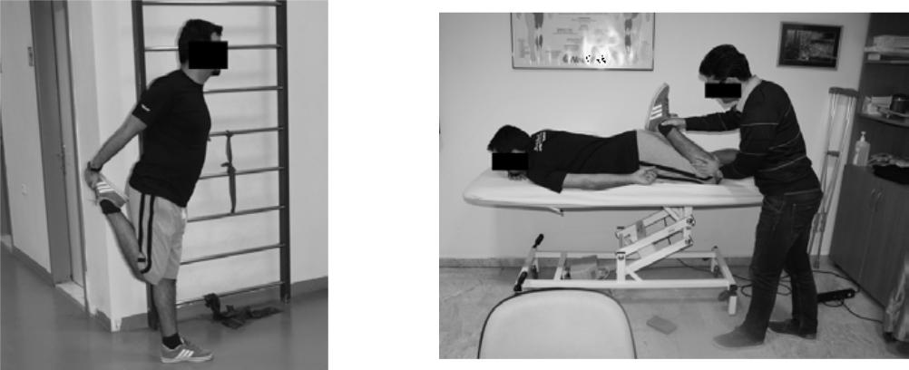

Figure 1: First unassisted stretching exercise Figure 2: First assisted stretching exercise
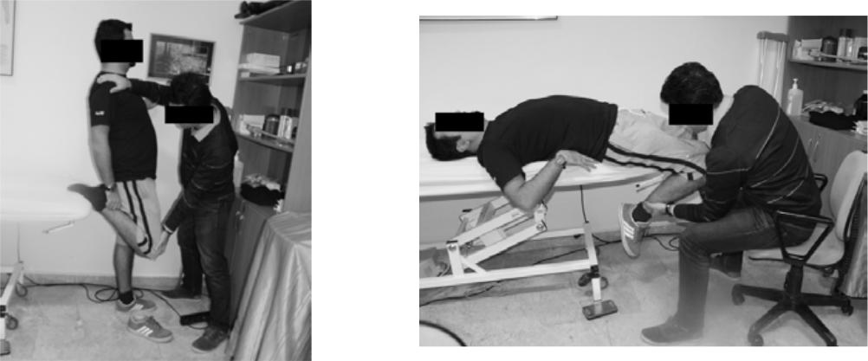

Figure 3: Second assisted stretching exercise Figure 4: Third assisted stretching exercise

Mehmet Mesut Çelebi, Savaş Kudaş, Ali Murat Zergeroğlu 189

Ankara Üniversitesi Tıp Fakültesi Mecmuası 2016, 69 (3)

Significant increases have been achieved in ROM after stretching in both soccer players and sedentary individuals (21.7 ± 5.3, 22.8 ± 5.4 and 22.5 ± 5,1, 24.5 ± 5,7, respectively)

4. Discussion

The negative effects of SS on muscle force and muscle force production has previously been reported (1,3,4,6,10-16,28). Our study showed that SS at 60 and 300 degrees per second did not affect the PT in the stretched extremity. These findings were in agreement with several previous studies (2,17,26).

Previous studies suggested that the
mechanisms responsible for deterioration in muscle force after stretching involved both neurologic and mechanical changes (10,12,17). Neurologic changes in other words, a decrease in neuromuscular activity were seen during a static stretching period of 30 seconds, but were restored immediately after stretching (29). Furthermore, mechanical changes characterized by a decrease in the viscoelasticity of the muscle and tendon structures were seen following a static stretching period of 30 seconds (30). However, the viscoelasticity of the muscle and tendon structures returned to normal within 30 seconds after 45 seconds of static stretching (30). In addition, neurologic and mechanical changes after a static stretching of 30 seconds may not continue. Accordingly, a 30-second static stretching may not decrease muscle performance. Therefore, it is necessary to clarify the

REFERENCES

- Cramer JT, Housh TJ, Weir JP et al. The acute effects of static stretching on peak
torque, mean power output, electromyography, and mechanomyography. Eur J Appl Physiol 2005; 33: 530–539.

- Egan AD, Cramer JT, Massey LL et al. Acute effects of static stretching on peak torque and mean power output in national collegiate athletic association division I women’s basketball players. J Strength Cond Res 2006; 20: 778-782.

effect of static stretching over a period of 30 seconds on muscle performance so as to decide whether static stretching should be done during warm-up exercises or not.

The purpose of this study was to determine the effect of a 30-second static stretching on muscle performance. However, Guissard et al. (29) reported that the level of neuromuscular activity, as measured with Hoffmann reflex, decreased during a 30-second static stretching, but it was restored immediately after the stretching. On the other hand, no evidence has been put forward regarding the acute effects of static stretching for 30 seconds on the viscoelasticity of muscle-tendon structures so far. However, Magnusson et al. (30) reported that the deterioration of stress relaxation, measured as an index of the viscoelasticity of muscle-tendon structures, disappeared in 30 seconds after a static stretching of 45 seconds.

Siatras et al (31). recommended that stretching exercises longer than 30 seconds should be avoided before performances that require maximal strength. Pinto et al. (5) suggested that

- 30-second stretching period could be used if necessary, while 60-second stretchings should be avoided as much as possible. For that reason, if stretching is going to be used for a sports-specific warm-up program, the effects of different periods of stretching should be investigated.

Nevertheless, Simic et al. (24) and Kay and Blazevich (25) concluded that

- Samuel MN, Holcomb WR, Guadagnoli MA et al. Acute effects of static and ballistic stretching on measures of strength and power. J Strength Cond Res 2008; 22: 1422–1428.

- Winchester JB, Nelson AG, Landin D et al. Static stretching impairs sprint performance in collegiate track and field athletes. J Strength Cond Res 2008; 22: 13-18.

- Pinto MD, Wilhelm EN, Tricoli V et al. Differential effects of 30- vs. 60-second

static stretching exercises of less than a 45-second duration could be used in

pre-exercise routines without increasing the risk of loss of muscle power and performance, but longer periods of stretching (>=60 seconds) were found to be more likely to lead to a mild to moderate degree of performance loss. Similarly, Ogura et al. (19) found a significant loss after a stretching of 60 seconds, but it was not seen after a 30-second stretching. Yamaguchi and Ishii (20) put forward that a 30-second static stretching did not affect the muscle performance.

We concluded that 30 seconds SS can not affect muscular performance but improved flexibility. Thirty second stretching exercises as part of a warm-up to be proposed to the coaches.

Acknowledgments: No financial support was received for this study.

Ankara University Human Participant Research Ethics Committee approved all the procedures used in this investigation.

The authors would like to thank our subjects for their participation and Meltem Dagdemir for the isokinetic measurement.

Author contrubutions: Mehmet Mesut Celebi supervised the development of the work, helped in data interpretation and manuscript evaluation. Savas Kudas helped to evaluate and edit the manuscript. Ali Murat Zergeroglu performed the analysis on all samples, interpreted data, wrote the manuscript.

static muscle stretching on vertical jump performance. J Strength Cond Res 2014;

28: 3440–3446.

- Rubini EC, Costa AL, Gomes PS . The effects of stretching on strength performance. Sports Med 2007; 37: 213-224.

- Kallerud H, Gleeson N. Effects of stretching on performances involving stretch-shortening cycles. Sports Med 2013; 43: 733–750.

- Effects of Static Stretching on Quadriceps Peak Torque and Hip Range of Motion in Professional Soccer Players and Sedentary Subjects

Journal of Ankara University Faculty of Medicine 2016, 69 (3)

- Nelson RT, Bandy WD. Eccentric Training and Static Stretching Improve Hamstring Flexibility of High School Males. J Athl Train 2004; 39: 254–258.

- Jamtvedt G, Herbert RD, Flottorp S et al. A pragmatic randomized trial of stretching before and after physical activity to prevent injury and soreness. B J Sports Med 2010; 44: 1002-1009.

- Kokkonen J, Nelson AG, Cornwell A. Acute Muscle Stretching Inhibits Maximal Strength Performance. Res Q Exerc Sport 1998; 69: 411-415.

- Avela J, Finni T, Liikavainio T et al. Neural and mechanical responses of the triceps surae muscle group after 1 h of repeated fast passive stretches. J Appl Physiol 2004; 96: 2325-2332.

- Fowles JR, Sale DG, MacDougall JD. Reduced strength after passive stretch of the human plantar flexors. J Appl Physiol 2000; 89: 1179–1188.

- Power K, Behm D, Cahill F et al. An acute bout of static stretching: effects on force and jumping performance. Med Sci Sports Exerc 2006; 36: 1389-1396.

- Marek SM, Cramer JT, Fincher AL et al. Acute Effects of Static and Proprioceptive Neuromuscular Facilitation Stretching on Muscle Strength and Power Output. J Athl Train 2005; 40: 94–103.

- Nelson AG, Kokkonen J, Eldredge C. Strength Inhibition Following an Acute Stretch is not Limited to novice Stretchers. Res Q Exerc Sport 2005; 76: 500-506.

- Evetovich TK, Cain RM, Hinnerichs KR et al. Interpreting normalized and non-normalized data after acute static stretching in athletes and nonathletes. J Strength Cond Res 2010; 24: 1988-1994.

- Young W, Elliott S. Acute effects of static stretching, proprioceptive neuromuscular facilitation stretching, and maximum voluntary contractions on explosive force production and jumping performance. Res Q Exerc Sport 2001; 72: 273–279.

- Wong PL, Lau PW, Mao de W et al . Three days of static stretching within a warm-up does not affect repeated-sprint ability in youth soccer players. J Strength Cond Res 2011; 25: 838-845.

- Ogura Y, Miyahara Y, Naito H et al . Duration of static stretching influences muscle force production in hamstring muscles. J Strength Cond Res 2007; 21: 788-792.

- Yamaguchi T, Ishii K. Effects of static stretching for 30 seconds and dynamic stretching on leg extension power. J Strength Cond Res 2005; 19: 677–683.

- O'Connor DM, Crowe MJ, Spinks WL . Effects of static stretching on leg power during cycling. J Sports Med Phys Fitness 2006; 46: 52-56.

- Behm DG, Bambury A, Cahill F, Power K. Effect of acute static stretching on force, balance, reaction time, and movement time. Med Sci Sports Exerc 2004; 36: 1397–1402.

- Reiman M, Bastian S, Lehecka B et al. The acute effects of static stretching on leg torque production after a 30 second static

stretch versus no stretch. Proceedings of the 4th Annual GRASP Symposium, Wichita State University, 2008.

- Simic L, Sarabon N, Markovic G. Does pre-exercise static stretching inhibit maximal muscular performance? A meta-analytical review. Scan J Med Sci Sports 2013; 23: 131–148.

- Kay AD, Blazevich AJ. Effect of acute static stretch on maximal muscle performance: A systematic review. Med Sci Sports Exerc 2012; 44: 154–164.

- Winke MR, Jones NB, Berger CG et al . Moderate static stretching and torque production of the knee flexors. J Strength Cond Res 2010; 24: 706-710.

- Biodex Pro Manual, Shirley, NY. Biodex Medical System, 1998.

- Sekir U, Arabaci R, Akova B et al. Acute effects of static and dynamic stretching on leg flexor and extensor isokinetic strength in elite women athletes. Scan J Med Sci Sports 2010; 20: 268–281.

- Guissard N, Duchateau J, Hainaut K. Muscle stretching and motoneuron excitability. Eur J Appl Physiol 1988; 58: 47-52.

- Magnusson SP, Aagaard P, Nielson JJ. Passive energy return after repeated stretches of the hamstring muscle- tendon unit. Med Sci Sports Exerc 2000; 32: 1160–1164.

- Siatras T, Papadopoulos G, Mameletzi D et al. Static and dynamic acute stretching effect on gymnasts speed in vaulting. Ped Exerc Sci 2003; 15: 383–391.

Mehmet Mesut Çelebi, Savaş Kudaş, Ali Murat Zergeroğlu 191

